What did our counselor do during the 1st semester to impact our school?
Committed  Committed to present a workshop to teachers on how to help students manage their test anxiety | Connected  Connected 56 parents to counseling and other resources in the community | 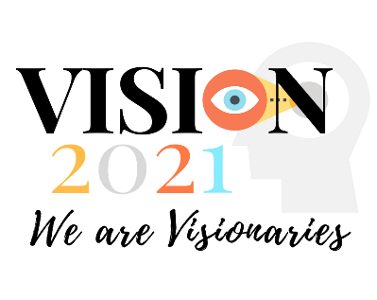 | Sponsored  Sponsored the student council for monthly meetings
Brought  Brought 92 students through the small group counseling process on topics such as grief, anxiety and anger | Co-Wrote  Co-wrote 12 new lessons on stress management | Managed  Managed a new pen pal program for 8th graders | Introduced  Introduced parents to strategies to help their child self-soothe
 | Served  Served 18 students that are experiencing homelessness | Taught  Taught 34 guidance lessons, including 18 CASES lessons | Curated  Curated student submissions for favorite quote of the week on the Friday announcements
Collaborated  Collaborated with the coordinated health team to host a family health fair | Primed  Primed students to use good communications during their  Enterprise Fair (a project based learning experience) | Welcomed  Welcomed 29 new students to our school and showed them around our building | 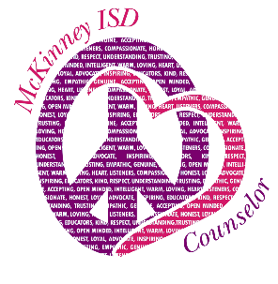
Troubleshot  Troubleshot a schedule conflict for a guest speaker |  | Directed  Directed students in 7 video announcements | Tweeted  Tweeted action shots of random acts of kindness to our #misdliveskind
Learned  Learned about the best strategies to help a child who is avoiding school. | Co-Lead  Co-Lead 38 annual meetings for our 504 students | Participated  Participated in 17 A-Team meetings to help our campus achieve its goals. | Supported  Supported 6 students that were considering self-harm
Attended  Attended 26 hours of professional development to help me serve the best students in MISD | Extended  Extended our learning about restorative practices by sharing articles and resources with the staff. | 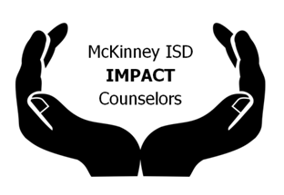 | Photographed  Photographed 104 silly faces at the fall carnival photo booth

